**Java Project**

**Project Topic** :**Website For Temple Management System Using Servlet with Database(MySql).**

**DataBase And Website Flow Chart:**

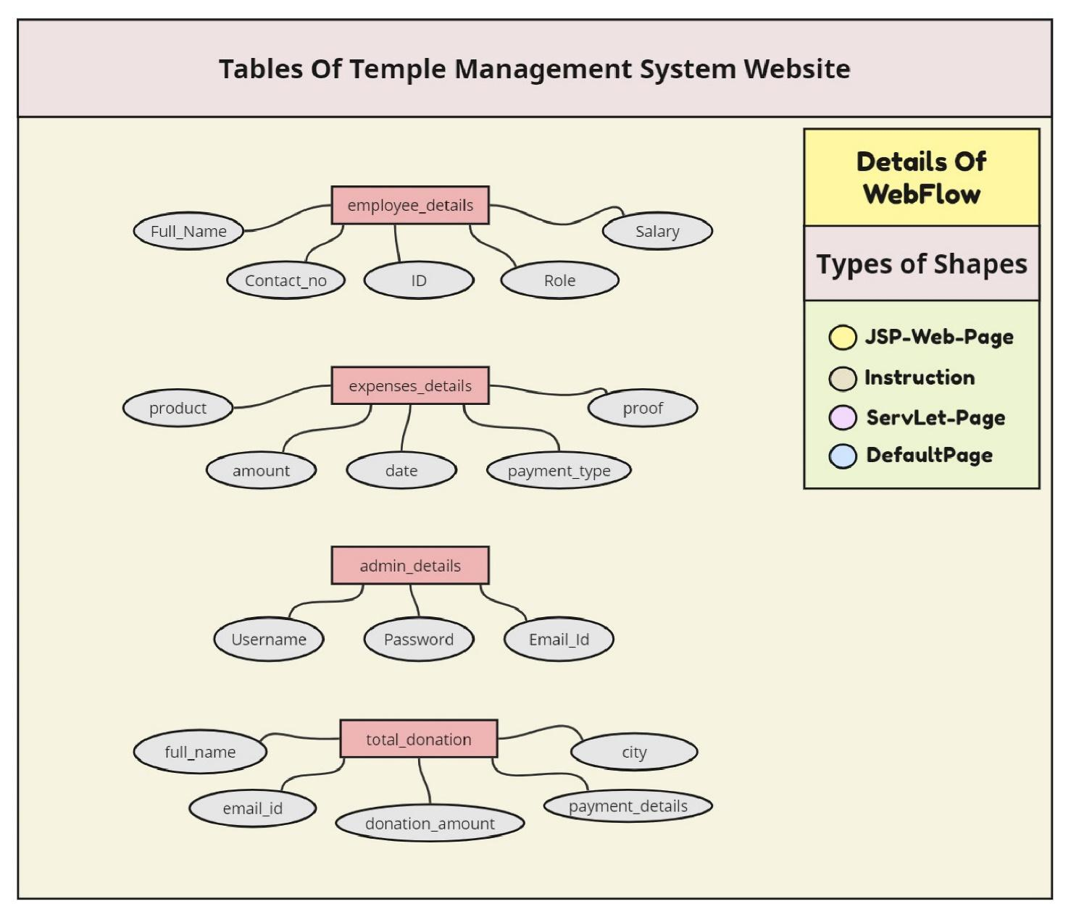

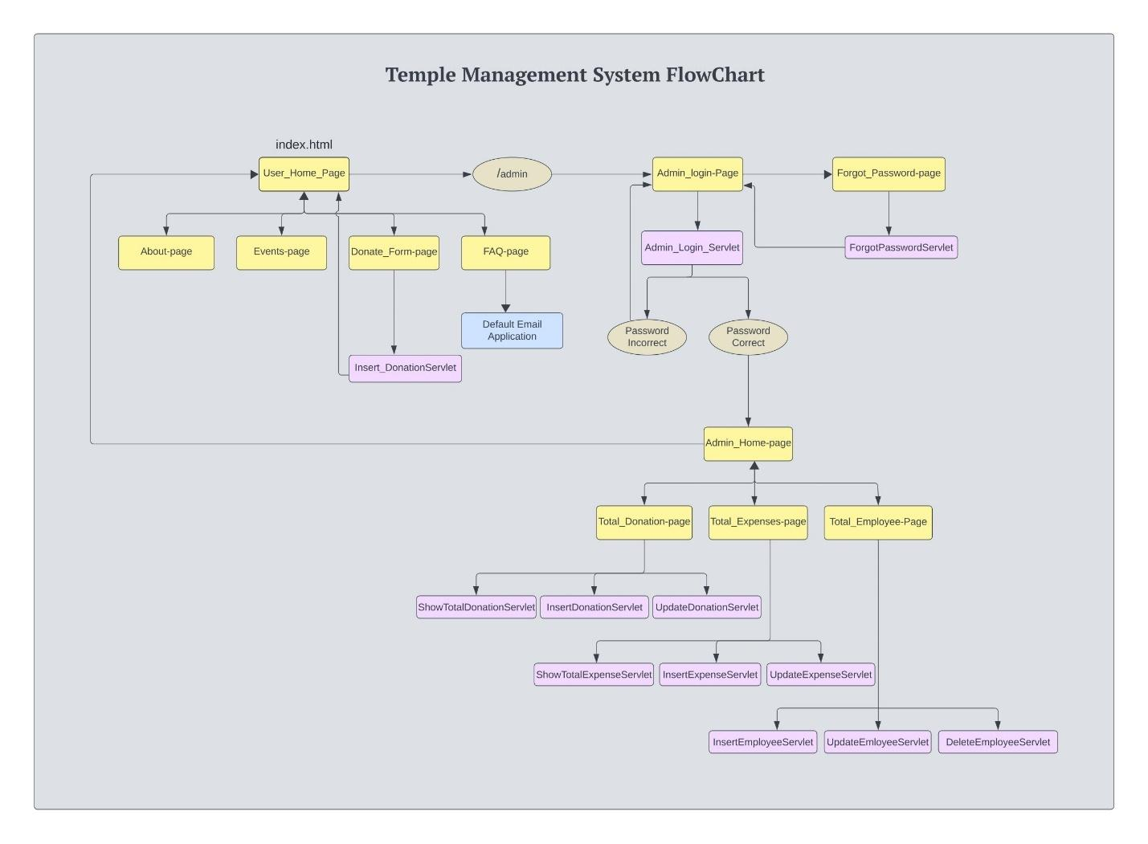

**UserSite:**

HomePage:

The homepage serves as the gateway to the temple management system website, offering visitors a comprehensive overview of its key features and offerings. It is designed to provide easy access to various sections of the website, allowing users to navigate seamlessly and explore the rich offerings of the Ram Mandir.

At the heart of the homepage is an engaging and interactive carousel featuring captivating images and videos that showcase the grandeur and significance of the Ram Mandir. This visually appealing element not only captivates the attention of visitors but also immerses them in the cultural and spiritual essence of the temple.

In addition to the carousel, the homepage features a section dedicated to recent posts, which highlights upcoming events, ceremonies, and other significant news related to the temple. This ensures that visitors are always up-to-date with the latest developments and activities happening at the Ram Mandir.

Furthermore, the homepage provides quick links to various sections of the website, enabling users to easily access specific information or functionalities of interest. Whether it's donating to support the temple, exploring upcoming events, learning about the history and significance of the Ram Mandir, or seeking answers to frequently asked questions, visitors can swiftly navigate to their desired destination with just a few clicks.

Overall, the homepage serves as a vibrant and informative introduction to the temple management system website, enticing visitors to delve deeper into its offerings and engage actively with the spiritual and cultural heritage of the Ram Mandir.

AboutUsPage:

The User_About page offers visitors a comprehensive overview of the Ram Mandir, providing detailed insights into its rich history, cultural significance, and architectural marvels. It serves as a digital repository of knowledge, allowing users to delve deep into the heritage and legacy of the temple.

One of the primary focuses of the User_About page is to educate visitors about the historical background of the Ram Mandir, tracing its origins and evolution over the centuries. Through engaging narratives and compelling visuals, users are transported back in time to witness the inception and growth of this sacred institution.

In addition to historical insights, the User_About page also delves into the cultural and spiritual significance of the Ram Mandir, highlighting its role as a beacon of faith and devotion for millions of devotees worldwide. Visitors gain a deeper understanding of the rituals, traditions, and customs associated with the temple, fostering a sense of reverence and connection to its sacred heritage.

Furthermore, the User_About page explores the architectural features and design elements of the Ram Mandir, showcasing its intricate craftsmanship and timeless beauty. Users are treated to virtual tours and detailed descriptions of the temple's layout, enabling them to appreciate its architectural splendor from the comfort of their homes.

Moreover, the User_About page sheds light on the economic impact of the temple, highlighting its contribution to the local community and economy. From generating employment opportunities to promoting tourism and trade, the Ram Mandir plays a vital role in fostering socio-economic development in its vicinity.

Overall, the User_About page serves as an informative and immersive journey into the heart and soul of the Ram Mandir, offering visitors a deeper appreciation of its historical, cultural, and spiritual significance.

DonatePage:

The User_Donate page provides visitors with a convenient and secure platform to make online donations in support of the construction and maintenance of the Ram Mandir. It is designed to facilitate seamless transactions, enabling users to contribute to the noble cause with ease and confidence.

At the core of the User_Donate page is a user-friendly donation form that streamlines the donation process and ensures a hassle-free experience for users. The form is intuitively designed, with clear instructions and prompts guiding users through each step of the donation process.

Users have the flexibility to choose their preferred donation amount and payment method, whether it's credit/debit card, online banking, or digital wallets. The User_Donate page employs robust security measures to safeguard users' sensitive information and protect against unauthorized access or fraudulent activities.

In addition to the donation form, the User_Donate page provides users with comprehensive information about the various initiatives and projects supported by their contributions. From infrastructure development to community outreach programs, users gain insight into how their donations are making a meaningful impact on the lives of others.

Furthermore, the User_Donate page offers transparency and accountability by providing regular updates and progress reports on the utilization of funds. Users can track the status of ongoing projects and see firsthand the tangible results of their generosity, fostering trust and confidence in the temple management's stewardship.

Overall, the User_Donate page serves as a vital fundraising tool for the Ram Mandir, empowering users to contribute towards its growth and sustainability while reaffirming their commitment to the values of compassion and philanthropy.

FaqPage:

The Faq_Page serves as a comprehensive resource for visitors seeking answers to commonly asked questions related to the Ram Mandir. It is designed to provide clear and concise explanations on a wide range of topics, addressing users' queries and concerns effectively.

One of the key features of the Faq_Page is its user-friendly interface, which allows visitors to easily browse through a curated list of frequently asked questions. The questions are organized into logical categories, making it convenient for users to find information relevant to their interests or needs.

Each question on the Faq_Page is accompanied by a detailed answer that provides in-depth insights and clarification on the topic at hand. Whether it's inquiries about making donations, booking religious ceremonies, or understanding temple etiquette, users can rely on the Faq_Page as a trusted source of information.

Moreover, the Faq_Page is regularly updated and expanded to address emerging queries and topics of interest, ensuring that users have access to the most relevant and up-to-date information. Visitors can also submit their questions directly through the Faq_Page, enabling the temple management to provide personalized responses and further enhance the user experience.

In addition to text-based content, the Faq_Page may also incorporate multimedia elements such as videos, infographics, or interactive tutorials to complement the explanations and engage users more effectively.

Overall, the Faq_Page serves as a valuable tool for empowering visitors with knowledge and fostering a deeper understanding of the Ram Mandir and its practices, ultimately enriching their spiritual journey and strengthening their connection to the temple community.

EventsPage:

The User_Events page serves as a hub for showcasing past and upcoming events related to the Ram Mandir, providing visitors with comprehensive information about their significance, schedule, and other relevant details. It is designed to keep users informed and engaged with the temple's calendar of activities and ceremonies.

One of the primary features of the User_Events page is its interactive interface, which allows users to explore a diverse range of events through visually appealing displays and intuitive navigation. Whether it's religious festivals, cultural celebrations, or community gatherings, users can easily browse through the event listings and find activities of interest.

Each event on the User_Events page is accompanied by detailed descriptions, highlighting its historical and cultural significance, as well as practical information such as dates, times, and locations. Users can also access additional resources or related content to deepen their understanding of the event and its context within the temple's calendar.

Furthermore, the User_Events page may incorporate interactive features such as event registration forms, allowing users to RSVP for upcoming events or reserve seats for specific ceremonies. This enhances user engagement and facilitates seamless coordination for both attendees and organizers.

Moreover, the User_Events page is regularly updated with new event listings and announcements, ensuring that users have access to the latest information and can plan their visits to the temple accordingly. Visitors can also subscribe to event notifications or newsletters to stay informed about upcoming activities and opportunities for participation.

Overall, the User_Events page serves as a vibrant and dynamic platform for promoting community engagement and fostering a sense of belonging within the temple community, enabling users to connect with the rich traditions and spiritual practices of the Ram Mandir.

**Admin Site:**

AdminLoginPage:

The AdminLoginPage serves as the entry point for administrators to access the temple management system. Upon entering correct login credentials, administrators are redirected to the Admin_Home_Page, granting them access to administrative functionalities. In case of incorrect login attempts, administrators remain on the same page, providing them with an opportunity to retry or access the ForgotPasswordPage1 for password reset.

ForgotPasswordPage:

The ForgotPasswordPage1 serves as a mechanism for administrators to reset their passwords in case they forget them. Administrators can initiate the password reset process by entering their email addresses. Upon submission, a password reset link is sent to the provided email address, enabling administrators to create a new password securely. This feature ensures data security and helps administrators regain access to their accounts in the event of forgotten passwords.

AdminHomePage:

The Admin_Home_Page serves as the central hub for administrators upon logging into the system. It provides a comprehensive overview of key metrics essential for managing the temple efficiently. Here, administrators can quickly access vital information such as total donations received, expenses incurred, and the current employee count, enabling them to make informed decisions and track the financial health of the temple. Additionally, the Admin_Home_Page offers intuitive navigation options, allowing administrators to seamlessly transition between different sections of the application and perform various tasks with ease.

AdminTotalDonationPage:

The Donation_Display page presents a comprehensive table showcasing all donations received by the temple. It includes crucial details such as the donation amount, date, payment proof, and the donor's name. Admins can efficiently search for donations based on donor names and manage them effectively. This functionality allows administrators to track and organize incoming donations, ensuring transparency and accountability in financial transactions.

AdminTotalExpensesPage:

Similar to the Donation_Display page, the Expenses_Display page exhibits a table listing all expenses incurred by the temple. It displays essential information such as the expense amount, date, payment details, and the products purchased using those expenses. Admins can search for expenses based on expense types and manage them efficiently. This feature enables administrators to monitor and regulate the temple's expenditures, ensuring prudent financial management and budgetary control.

AdminTotalEmployeePage:

The Employee_Display page provides a detailed table presenting information about all employees working for the temple. It includes employee names, contact numbers, IDs, roles, salaries, and actions (update/delete). Administrators can conveniently search for employees based on their names and manage employee data effectively. This functionality facilitates efficient human resource management, allowing administrators to oversee staffing needs, roles, and responsibilities within the temple organization.

**Servlet Function:**

InsertionOfData:

This servlet handles the insertion of new data into the system, such as donations, expenses, or employee records. It receives data from a form submitted by the user, connects to the database, and executes an SQL INSERT query to add the new data to the relevant table. Upon successful insertion, it sends a response indicating the success of the operation.

DeletionOfData:

This servlet manages the deletion of existing data from the system, such as employee details. It receives the ID or key of the record to be deleted from the user's request, connects to the database, and executes an SQL DELETE query to remove the specified record from the corresponding table. It then sends a response indicating whether the deletion was successful or not.

UpdationOfData:

This servlet handles the updating of existing data within the system, such as modifying donation details, updating expense entries, or editing employee information. It receives updated data from the user's request, connects to the database, and executes an SQL UPDATE query to modify the relevant record in the database. Upon successful update, it sends a response confirming the success of the operation.

DisplayData:

This servlet is responsible for retrieving and displaying data from the database to the user interface. It executes an SQL SELECT query to fetch data from the specified table(s) in the database, processes the retrieved data, and generates HTML content to present it in a structured format on the web page. This servlet facilitates the visualization of data, such as displaying donation records, expense details, or employee information, to the users.

SearchData:

This servlet handles the searching and retrieval of specific data from the database based on user-defined criteria. It receives search parameters from the user's request, constructs an SQL query with appropriate search conditions, executes the query to fetch matching records from the database, and presents the results to the user interface. This servlet enables users to find and access specific information, such as searching for a particular donation, expense, or employee record, efficiently within the system.

FetchTotalAmount Servlet:

This servlet retrieves the total received from the database and sends it as a response to the user interface. It executes an SQL query to calculate the sum of particular column from the table, retrieves the total from the result set, and sends it back as a plain text response. This servlet provides functionality to display the aggregate Total of particular thing, allowing users to track the overall financial contributions made to the temple.

Pages Photos:

